- Introduction
  - Purpose of the system
    - The purpose of the system that Team Rocket is designing is to bring a new visitor experience to the St. Louis Zoo by providing updated information in an economical way while also being packaged with an interactive user experience. This system will help the zoo by not forcing them to replace the information multiple times within the placards located outside the cage of the animal. These displays are only allowed to display the maximum information that will fit on the slab. These displays will be replaced with smaller QR codes that can be scanned with the new St. Louis Zoo app which will redirect the user to the animal’s page in the app. Users can also utilize a search function to visit any animal’s page. This will allow the zoo to display as much information as they want as people will be directed to a scrolling page within the app that grabs information from the database allowing them to see multiple pictures, information on the animal, and quick access to other animals. This will require less upkeep and be easier on the human eyes. This will also keep traffic down as people will not be stopping as long at each individual slab. The text to voice functionality that most smart phones come packaged with would also allow blind visitors to hear about the animals. The littering of paper maps can be minimized by utilizing the map feature on the app. Finally, if the QR codes are prevalent around the zoo, then more visitors will be likely to download the app and utilize its features.
  - Scope of the system
    - Team Rocket will be delivering a product within six months to help the St. Louis Zoo develop an infrastructure for each animal. This infrastructure will consist of weather proof placards with QR codes that will allow an individual to see that specific animal’s information, post pictures, and access other animals for a different page of information. During this process we will need to create a database record of every animal in the zoo. In that database we need the animal name, QR code, information on animal, and pictures. The user will have to download the free St. Louis Zoo app from his/her Apple, Play, or Windows app store while the app will contain its own QR code scanner. The application will utilize the camera on a smart phone owned by the application's user to scan the QR code.
  - Objectives and success criteria of the project
    - Team Rocket’s goal is to create a system that will replace the current out dated system. The main objective is to create a database that will house descriptions of the animals in the zoo. Additional objectives include integrating a QR code scanner, search feature, picture upload capabilities, and a map into the app. It would be able to include more information than the current system of placards outside of the exhibits. The placards would be replaced with a QR code that links to the database and will pull the pertinent information from the database for the user to view. The success criteria for the project focuses on providing an app that allows the user to view animal and map information. The rest of the success criteria includes accessibility at any age, reliable database, a fast response time with the app, availability across platforms, and conservatively moderated.
  - Definitions, acronyms, and abbreviations
    - Definitions
      - Analysis Object Model - The system has classes with nontrivial states and many relationships between the classes that comes after requirement elicitation (Bruegge).
      - Application - A program (as a word processor or a spreadsheet) that performs one of the major tasks for which a computer is used (Merriam-Webster.com).
      - Database - A usually large collection of data organized especially for rapid search and retrieval (as by a computer) (Merriam-Webster.com).
      - Download - An act of moving or copying a file, program, etc., from a usually larger computer system to another computer or device (Merriam-Webster.com).
      - Dynamic Model - Describes the components of the system that have interesting dynamic behavior (Bruegge).
      - Image Gallery - A group or collection of images (Merriam-Webster.com).
      - Infrastructure - The underlying foundation or basic framework (as of a system or organization) (Merriam-Webster.com).
      - Functional Requirement - A requirement that is vital for a given program to operate successfully.
      - Mockup - A full-sized structural model built to scale chiefly for study, testing, or display (Merriam-Webster.com).
      - Non-functional requirement - A requirement that is not vital for a program to operate but is preferred for optimal operation.
      - Placard - A large notice or sign put up in a public place or carried by people (Merriam-Webster.com).
      - QR Code - A machine-readable code consisting of an array of black and white squares, typically used for storing URLs or other information for reading by the camera on a smartphone (Wikipedia contributors).
      - Scenario - An account or synopsis of a possible course of action or events (Merriam-Webster.com).
      - Smart Phone - A cell phone that includes additional software functions (as e-mail or an Internet browser) (Merriam-Webster.com).
      - Upload - To move or copy (a file, program, etc.) from a computer or device to a usually larger computer or computer network (Merriam-Webster.com).
      - Use Case Model - A list of steps, typically defining interactions between a role (known in Unified Modeling Language (UML) as an "actor") and a system, to achieve a goal (Wikipedia contributors).
    - Acronym
      - QR - Quick Response (Wikipedia contributors).
    - Abbreviation
      - App - Application
  - References
    - Definitions, acronyms, and abbreviations
      - Bruegge, Bernd. Dynamic Modeling. N.p.: n.p., n.d. Web. 2 Dec. 2014. <http://wwwbruegge.in.tum.de/lehrstuhl_1/files/teaching/ws0607/Software%20Engineering%20I/L10_DistDynamicModeling.pdf>.
      - Merriam-Webster.com. Merriam-Webster, n.d. Web. 1 Dec. 2014. <http://www.merriam-webster.com/dictionary/>.
      - Wikipedia contributors. "QR code." Wikipedia, The Free Encyclopedia. Wikipedia, The Free Encyclopedia, 1 Dec. 2014. Web. 1 Dec. 2014.
    - Similar projects and existing systems
      - "A Complete Mobile App and Web Solution for Zoos, Parks, Aquariums and Attractions." Capacity. Speak Creative, n.d. Web. 24 Nov. 2014. <http://www.capacity.is/>.
        - Capacity is a similar system to the Rocket Zoo App project. It offers features specific to zoos, parks, and other attractions that are much like our proposed system which provides an idea to base our system off of during development.
      - "Animals." Cleveland Metroparks Zoo. Cleveland Metroparks, n.d. Web. 24 Nov. 2014. <http://www.clevelandmetroparks.com/Zoo/Zoo-Animals.aspx>.
        - The Cleveland Metroparks Zoo provides a database of the animals at their zoo. A similar database would be used for the Rocket Zoo App which would be accessed when scanning a QR code or through accessing the database directly with the search feature within the app.
      - "Zxing." GitHub. GitHub, Inc., n.d. Web. 24 Nov. 2014. <https://github.com/zxing/zxing>.
        - Zxing is an image processing library that is used for reading 1D and 2D barcodes. This library could be implemented in the Rocket Zoo App to provide the ability to read QR codes which can provide a reference to a database entry for the specified animal.
    - Facts
      - "Corporate Acrylic Plaque Black Marble Wall Placard Award." Dick's Trophies. N.p., n.d. Web. 24 Nov. 2014. <http://dickstrophies.com/shopping-cart/catalog/display-single-product.php?CSN=32qsPC22h&PSN=32qsP6y64&HATC=No&HPP=No>.
      - "Saint Louis Zoo Fact Sheet." Saint Louis Zoo. Saint Louis Zoo, n.d. Web. 24 Nov. 2014. <http://www.stlzoo.org/about/contact/pressroom/factsheet/>.
    - Tools
      - "ArgoUML." Argouml.tigris.org. CollabNet, n.d. Web. 24 Nov. 2014. <http://argouml.tigris.org/>.
      - Atlassian SourceTree was available on the lab computers.
      - "Balsamiq." Rapid, Effective and Fun Wireframing Software. Balsamiq Studios, LLC, n.d. Web. 24 Nov. 2014. <https://balsamiq.com/>.
    - Images and animal information filler
      - Empress Green Marble. Digital image. ShihwaStone. ShihwaStone, n.d. Web. 25 Nov. 2014. <http://www.shihwastone.com/images/empress_green_marble.jpg>.
      - "Fennec Fox." National Geographic. National Geographic Society, n.d. Web. 23 Nov. 2014. <http://animals.nationalgeographic.com/animals/mammals/fennec-fox/>.
      - Fennec Fox and Lemur. Digital image. Alex Limi. N.p., n.d. Web. 24 Nov. 2014. <http://limi.net/media/fennec-fox-and-lemur.jpg/image>.
      - Fennec Foxes. Digital image. Antalik. N.p., n.d. Web. 24 Nov. 2014. <http://www.antalik.com/wp-content/uploads/2010/11/Fennec-foxes-11.jpg>.
      - "QR Code Generator." QRStuff. QRStuff, n.d. Web. 23 Nov. 2014. <http://www.qrstuff.com/>.
      - Saint Louis Zoo Logo. Digital image. Mizzou. University of Missouri, n.d. Web. 25 Nov. 2014. <http://mizzoudata.imodules.com/s/1002/images/editor/saint_louis_zoo_logo.png>.
      - Saint Louis Zoo Logo. Digital image. Saint Louis Zoo. Saint Louis Zoo, n.d. Web. 24 Nov. 2014. <http://www.stlzoo.org/>.
      - /u/ibra038. QR Scanner for Camera. Digital image. Imgur. N.p., n.d. Web. 24 Nov. 2014. <http://i.imgur.com/d8yrqMS.jpg>.
      - Zoo Map 2014. Digital image. Saint Louis Zoo. Saint Louis Zoo, n.d. Web. 24 Nov. 2014. <http://www.stlzoo.org/files/7014/0120/7817/Zoo_Map_2014_PDF.pdf>.
  - Overview
    - The Team Rocket Zoo App will deliver a new visitor experience for the St. Louis Zoo by integrating new placards with QR codes into the zoo that will allow the visitors to utilize an app on their personal smart phone with a QR code scanner and search feature to learn about the zoo's map and animals via a database while also interacting with other visitors by participating in a public image gallery. This app will cater to its wide audience by implementing essential requirements to please any age and leave the user with a favorable impression of the zoo.
- Current system
  - The current system at the St. Louis Zoo is not technically inclined. They use physical signs called placards placed on the animal's exhibit fences to help the visitors learn more about the species. They are not very large and usually contain about a paragraph of information about the animal. The signs themselves are rarely updated. The red panda's sign had seen better days as it showed significant fading from sun exposure. Some animals are coupled with more reading material. The gorillas, for example, do have an additional tattered booklet with the family history as well as signs indicating their names. Easily the best way to learn about the animal is to be able to speak to the occasional zoo keeper observing the animals. As far as the St. Louis Zoo maps, they are distributed through physical brochures or visitors can follow the signs for a couple popular animals. This current system leaves significant room for improvement through technology which would also save this government-funded zoo money from printing updated signs and millions of brochures.
- Proposed system
  - Overview
    - The Team Rocket Zoo App will be able to scan QR codes via a smart phone's camera to retrieve information on an animal as well as upload and view images in an image gallery. It will also have a separate search function for universal animal access and a map feature. The app will ensure any smart phone user is capable of using the readily available app in a reliable, fast, and safe manner. A scenario, use case model, and dynamic model was developed for this system's functions. An analysis object model previews the database and class structure. Finally, mockups for the user interface were developed and labeled accordingly.
  - Functional requirements ("shall lists")
    - The application will allow the user to scan QR codes located in the zoo.
    - The application will allow users to retrieve information about the animals from a database.
    - The application will allow users to upload photos to an image gallery database.
    - The application will allow users to view photos stored in an image gallery database.
    - The application will allow users to view a map of the zoo.
    - The application will allow users to search the animal database.
  - Nonfunctional requirements
    - Usability
      - It must be three feet tall that way visitors of all ages will be able to use the Team Rocket app in comfort.
      - The system must be easy enough for children to be able to use.
    - Reliability
      - The database must always be available during zoo hours.
    - Performance
      - The user must be able to get results from database within 10 seconds.
    - Supportability
      - The app must come with a help page to help users learn how to use the app.
    - Implementation
      - The placards with a QR code must be installed at every animal’s exhibit.
    - Interface
      - The system must coordinate with zoo’s colorful scheme.
    - Packaging
      - This app must be available in the Windows Store, the Google Play Store, and Apple App Store.
    - Legal
      - Images will have to be moderated by a staff member to avoid legal concerns with inappropriate content being uploaded by users.
  - System models
    - Scenarios
      - Statement of purpose: The purpose of the Team Rocket QR code scanner app is providing zoo goers with information on the animals in the zoo.
      - User: The user is the visitor that downloads the app.
      - The transaction: The transfer of information from our database to the user's Team Rocket app about a given animal.
      - Equipment: There should be a placard with a QR code on it around the zoo for each animal. Also, we should have a database to store all of the information. Then we need to have an application for users to actually be able to consume information.
      - Assumptions: The QR code is connected to the animal information in the database. Users will know how to use the app. Each animal will have enough information to be able to please the user. The zoo placards are weather proof.

Scenario name | useRocketZooApp
Participating actor instances | dan:User  larah:Moderator  phone:System
Flow of events | 1. Dan can search the zoo's map through the app on his phone to find out where the polar bears are located.  2. Dan walks up to the polar bear exhibit and wants to know more about the polar bears, so he opens up the Rocket Zoo App on his smart phone.  3. Next Dan can scan the QR code on the animal placard to find out more information about the polar bear.  4. Dan decides to take a picture of the polar bear.  5. Dan can upload the photo to the Rocket Zoo app database and give an associated email address to accompany the photo.  6. Larah examines the photo sent in by Dan and decides it is an appropriate image deserving approval.  7. The approved image will now appear in the animal's image gallery within the application.  8. Dan can use the search bar on the home screen to look up the polar bear's profile at any time.  9. Dan checks to see if the photo he uploaded was approved to the gallery at a later time.
    - Use case model
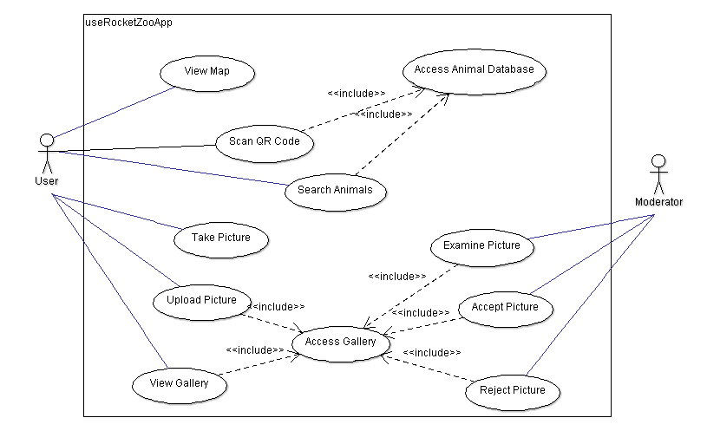
    - Analysis object model

      - Each entity must have a unique ID associated with it.
      - One image in each gallery will be featured on the top of the animal page by setting the Boolean to true.
      - An email will be associated with each image in case the uploader needs to be contacted.
      - Each image will be associated with a Boolean for whether it is approved by the moderator or not.
        - Images are always uploaded, but the Boolean will have to be set to true to appear in the animal’s image gallery.
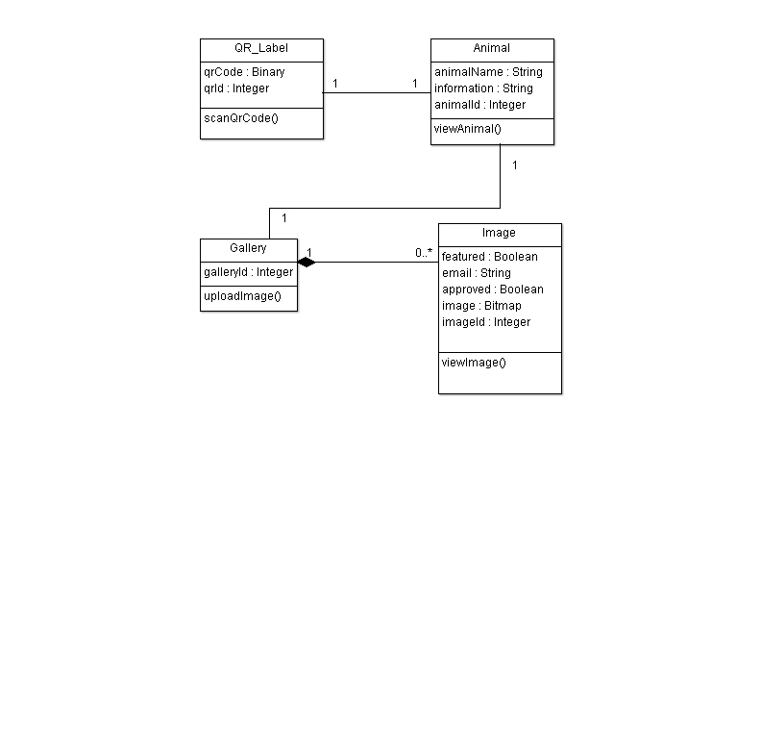
    - Dynamic model
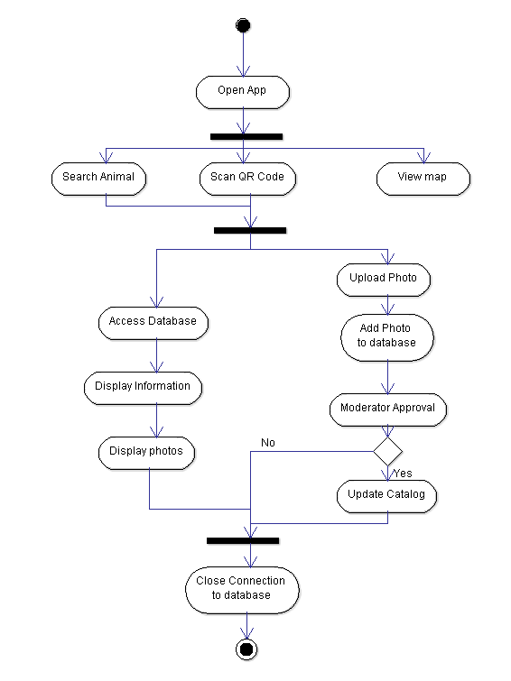
    - User interface—navigational paths and screen mock-ups
      - Home screen
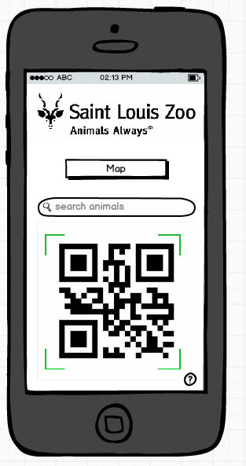
      - Home screen with keyboard
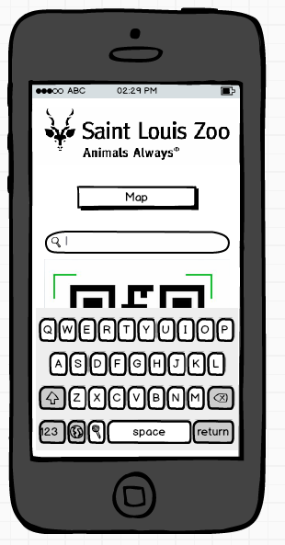
      - Animal page
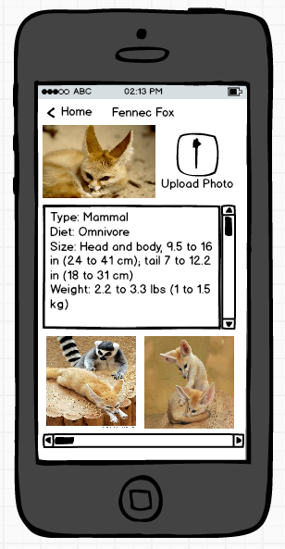
      - Map
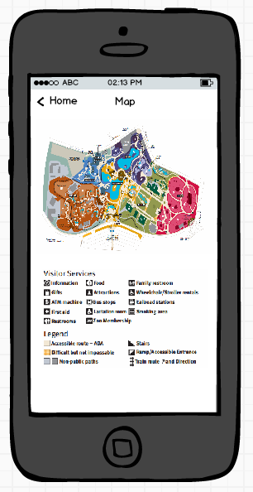
      - Upload picture
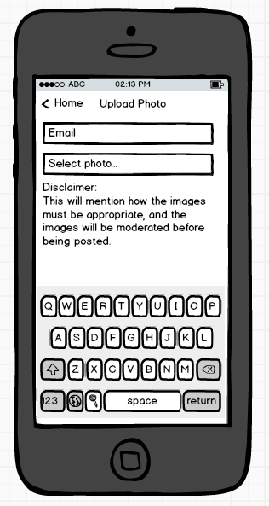
- Glossary
Analysis Object Model - The system has classes with nontrivial states and many relationships between the classes that comes after requirement elicitation (Bruegge).

Application (App) - A program (as a word processor or a spreadsheet) that performs one of the major tasks for which a computer is used (Merriam-Webster.com).

Database – A usually large collection of data organized especially for rapid search and retrieval (as by a computer) (Merriam-Webster.com).

Download - An act of moving or copying a file, program, etc., from a usually larger computer system to another computer or device (Merriam-Webster.com).

Dynamic Model - Describes the components of the system that have interesting dynamic behavior (Bruegge).

Image Gallery - A group or collection of images (Merriam-Webster.com).

Infrastructure - The underlying foundation or basic framework (as of a system or organization) (Merriam-Webster.com).

Functional Requirement - A requirement that is vital for a given program to operate successfully.

Mockup - A full-sized structural model built to scale chiefly for study, testing, or display (Merriam-Webster.com).

Non-functional requirement - A requirement that is not vital for a program to operate but is preferred for optimal operation.

Placard - A large notice or sign put up in a public place or carried by people (Merriam-Webster.com).

QR (Quick Response) - A machine-readable code consisting of an array of black and white squares, typically used for storing URLs or other information for reading by the camera on a smartphone (Wikipedia contributors).

Scenario - An account or synopsis of a possible course of action or events (Merriam-Webster.com).

Smart Phone - A cell phone that includes additional software functions (as e-mail or an Internet browser) (Merriam-Webster.com).

Upload - To move or copy (a file, program, etc.) from a computer or device to a usually larger computer or computer network (Merriam-Webster.com).

Use Case Model - A list of steps, typically defining interactions between a role (known in Unified Modeling Language (UML) as an "actor") and a system, to achieve a goal (Wikipedia contributors).

